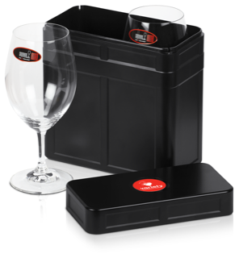 **Variety Car 222**

**Enjoy your wine with a touch of glass!**

***No matter where you roam, be it land or sea or foam you will always partake of your chosen wine from these magnificent Riedel Ouverture Magnum wine glasses which nestle safely in this cleverly designed valise!***

This South Australian designed and manufactured treasure has been selected for your enjoyment as you Sponsor Rod and me, the Wondering Wombats of Car 222, in the 2020 Variety SA Moto Run- raising money for special needs children in our state.

|  |
| --- |
| **Cost per Box - inclusive of container and glasses: $80.00 + 10% GST with Variety logo**  **+ $10.00 delivery within Australia [ ] or collect from Variety [ ] please indicate**  Contact Person: ___________________________________ No of boxes: _________________  Address: _____________________________________________________________________  Suburb: _____________________________ State: ______________ Postcode: ____________  Mobile:__ __________________________________Email: __________________________________ |

* I have paid by Direct Deposit the amount of $_____________into Car 222’s Variety’s Westpac Bank A/c
* ACC Name : Variety BSB 035-212 Acct #: 240647 Ref: **MOTO20/222**
* I hereby authorise my credit card to be charged with $________________ Visa or Mastercard
* Card Number; _ _ _ _ _ _ _ _ _ _ _ _ _ _ _ _ Expiry Date: _ _ / _ _
* Name on Card: ____________________________ Signature: ___________________________
* I have enclosed a cheque for $________________ (made payable to Car 222)

***Kindly return completed form to***: Sue Pearce, Car 222 111/123 Fisher Street, Fullarton SA 5063 or email to: [suepearce222@gmail.com](mailto:suepearce222@gmail.com) or text 0417857241

***All profits from this booking support Variety - the children’s charity through Car 222 and the 2020 Variety Moto Run***