Services Statement 
Horsepower Crew Pty Ltd
ABN: 94 614 122 726
For: jk@horsepowercrew.com
Variety SA
Natasha Morgan, Evangeline McAllen, Georgia Firth & other interested parties
Invoice Reference: 202410AMCR
Date of Issue: 09/11/2024
Page:1

Description Amount
Online sponsorship of 7 Livestreams/video’s, 7 pictures & 7 Reels of the Aussie Muscle Car Run in 2024
Budget was exclusively for Horsepower Crew services, posts to be staggered across Horsepower Crew & Variety SA Motoring FB pages
Boosting of posts was not optioned as an extra fee by client, this data & service is 100% Horsepower Crew Organic. $1,575
Date __________Activity Type________Reacts:______Comments___ Reach___Impressions____Other Clicks____________________Value
25th Oct Picture Post 148+16 23+4 9,153 9,366+246 352+171 $75
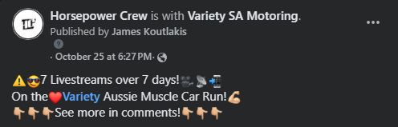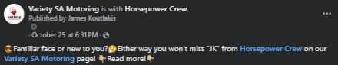

Hold Cntrl + Click the pics above to go to Facebook to view
Services Statement
Page: 2
Date __________Activity Type_________Reacts:______Comments___ Reach______Plays______Other Clicks____Link Clicks____Value
26th Oct Livestream 175+37 75+37 3,324+3,010 8,000+4,100 328+195 6 $150
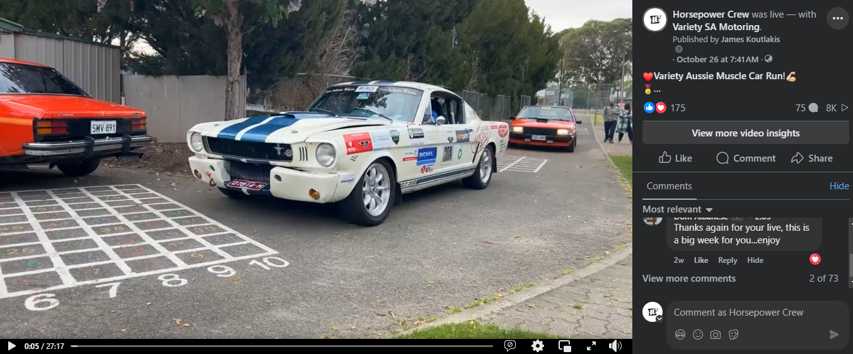
Hold Cntrl + Click the pics above to go to Facebook to view
Date __________Activity Type_________Reacts:______Comments___ Reach______Plays____Other Clicks___________________Value
26th Oct Livestream 140+38 18+6 3,201+657 6,200+972 345+77 $150
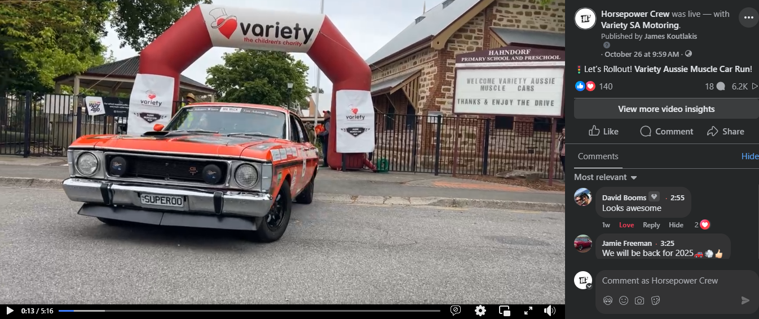
Hold Cntrl + Click the pics above to go to Facebook to view
Services Statement
Page: 3
Date __________Activity Type_________Reacts:______Comments___ Reach___Plays______Mins Viewed______________________Value
26th Oct Reel Video 626+2 27 4,100 56,300 6,700 $25
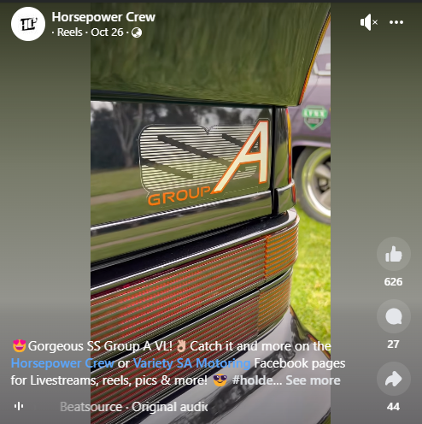
Date __________Activity Type_________Reacts______Comments___ Reach____Impressions____Other Clicks___________________Value
26th Oct Photo 4+10 0 3,982+990 4,195+1,035 228+13 $75
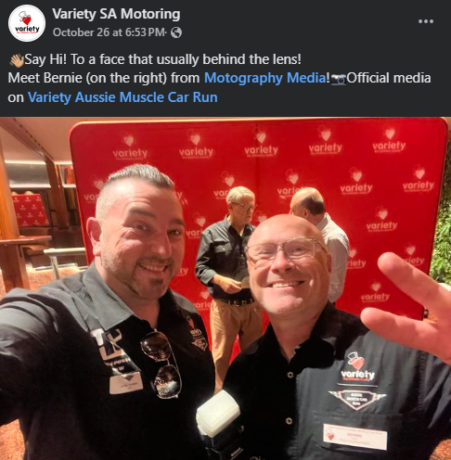
Hold Cntrl + Click the pics above to go to Facebook to view
Services Statement
Page: 4
Date __________Activity Type________Reacts:______Comments___ Reach____Plays____Mins Viewed_______________________Value
30th Jul Reel 20 6 1,584 5,300 548 $25
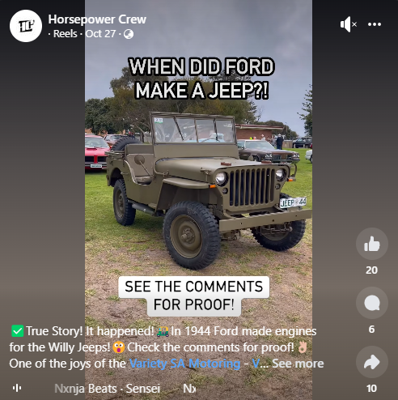
Date __________Activity Type_________Reacts:______Comments___ Reach______Plays_____Other clicks_____________________Value
27th Oct Livestream 78+22 18 +5 1,972+605 4,100+772 219+70 $150
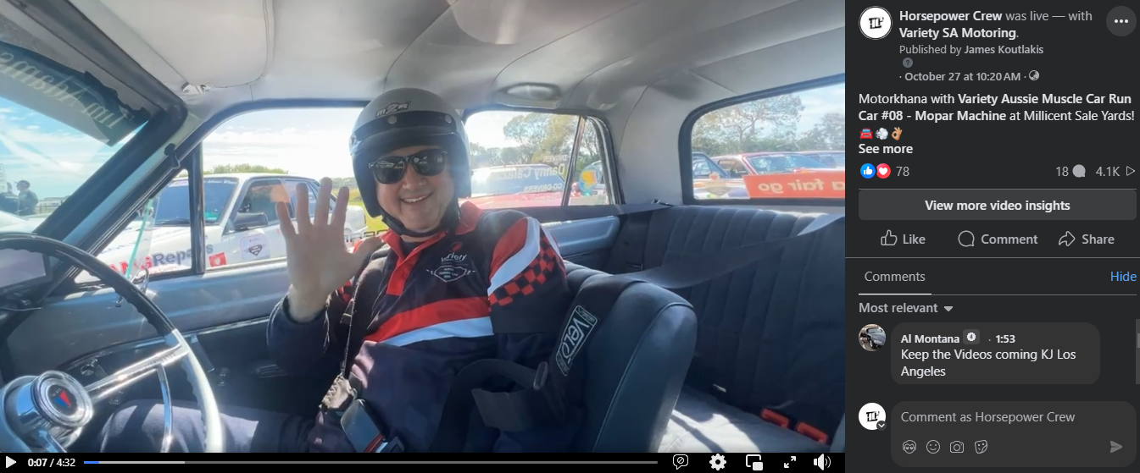
Hold Cntrl + Click the pics above to go to Facebook to view
Services Statement
Page: 5
Date __________Activity Type_________Reacts:______Comments___ Reach_______Plays_____Other clicks____________________Value
27th Oct Livestream 54+7 19 1,253+254 2,000+299 83+9 $150
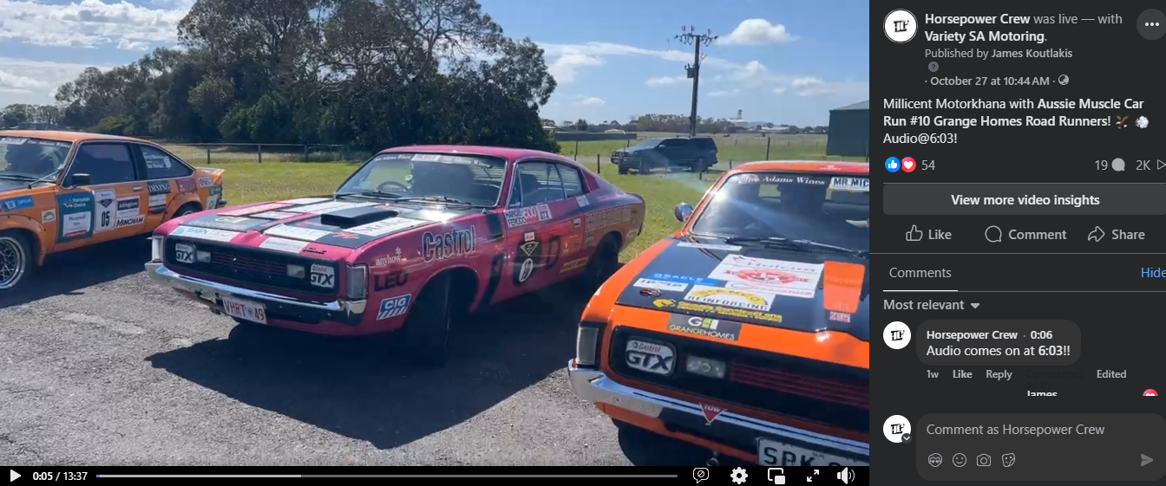
Date __________Activity Type_________Reacts:______Comments___ Reach_____Plays_____Other clicks_____________________Value
27th Oct Livestream 84+8 23 2,835+307 4,400+380 83+15 $150
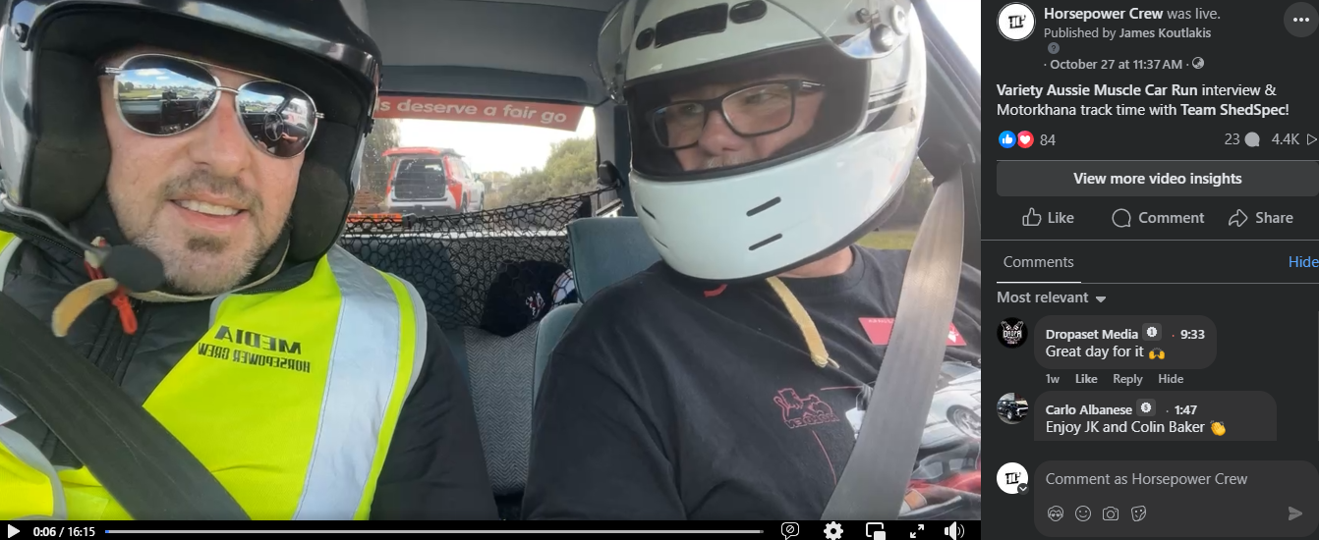
Hold Cntrl + Click the pics above to go to Facebook to view
Services Statement
Page: 6
Date __________Activity Type________Reacts:______Comments___ Reach____Plays____Mins Viewed_______________________Value
29th Oct Reel 583 25 29,800 33,500 3,800 $25
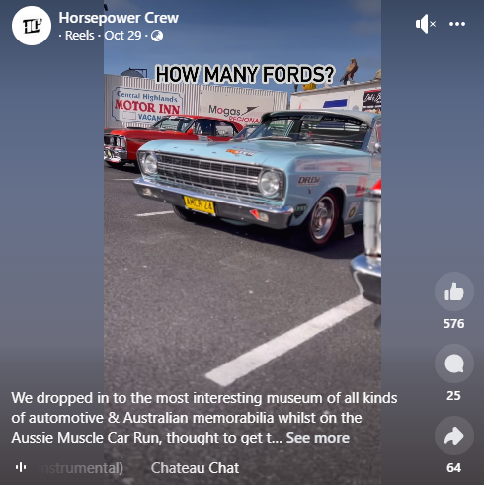
Date __________Activity Type________Reacts:______Comments___ Reach___Impressions____Other Clicks____________________Value
29th Oct Tail-End Tuesday 43 80 1,514 1,605 120 $75
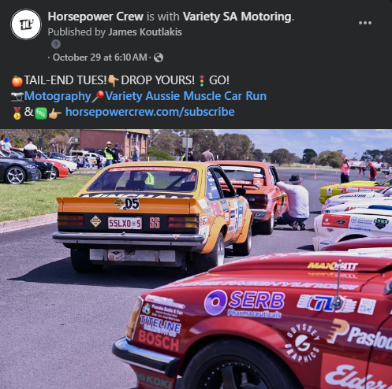
Hold Cntrl + Click the pics above to go to Facebook to view
Services Statement
Page: 7
Date __________Activity Type_________Reacts:______Comments___ Reach______Plays_____Other clicks_____________________Value
29th Oct Livestream 114+20 23+1 1,714+352 3,200+420 161+31 $150
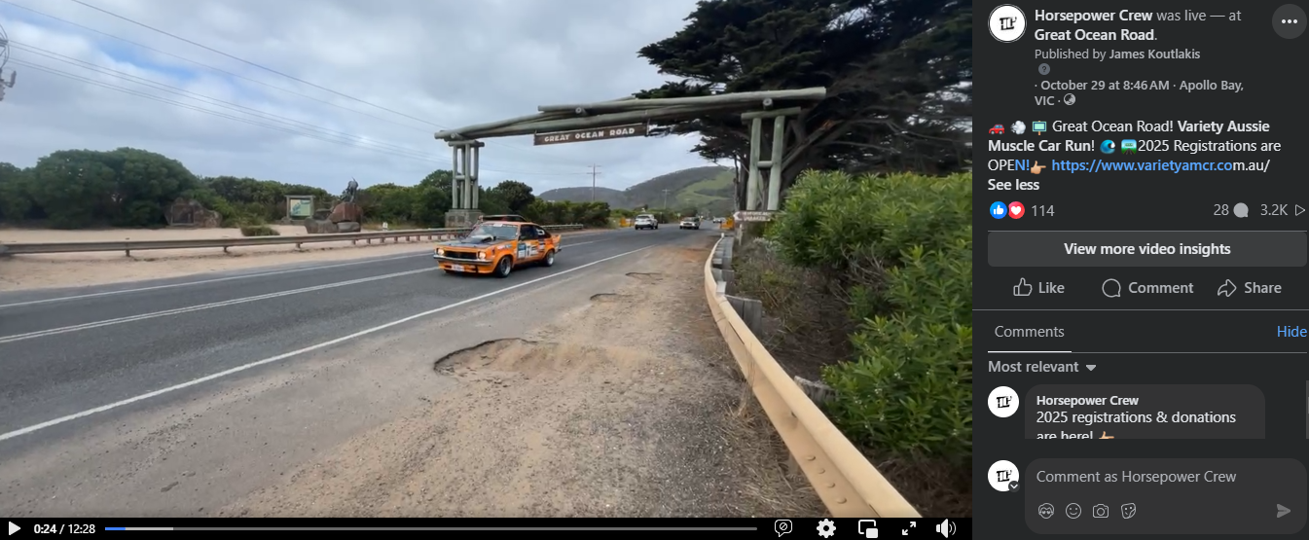
Date __________Activity Type_________Reacts:______Comments___ Reach___Plays_____Other clicks________________________Value
29th Oct Interview Video 65+11 14 2,063 3,300 256 $150
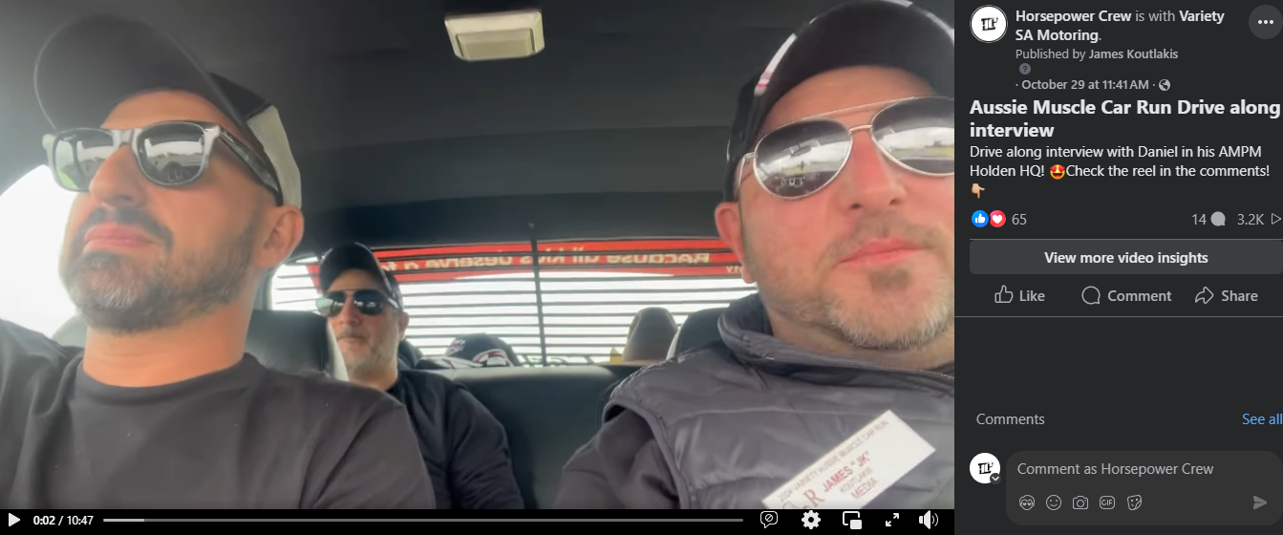
Hold Cntrl + Click the pics above to go to Facebook to view

Services Statement
Page: 7
Date __________Activity Type_________Reacts:______Comments___ Reach____Plays_____Other clicks_______________________Value
29th Oct Interview Video 34+33 2+5 1,714+2,190 2,700 170 $150
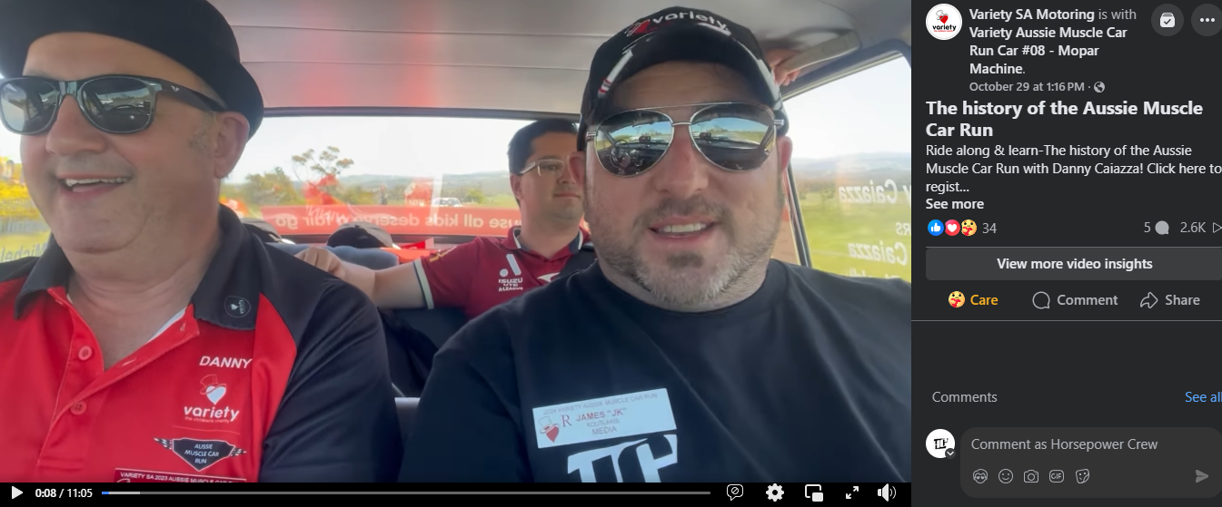
Date __________Activity Type________Reacts:______Comments___ Reach____Plays____Mins Viewed_______________________Value
29th Oct Reel 583 25 29,800 33,500 3,800 $25
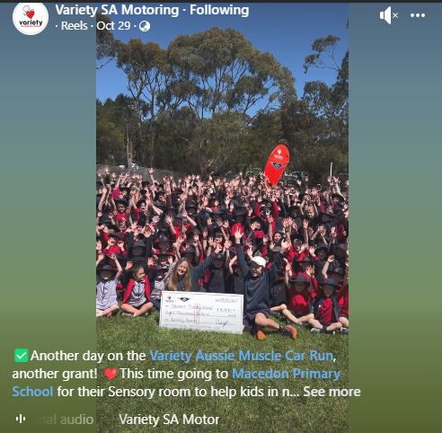
Hold Cntrl + Click the pics above to go to Facebook to view
Services Statement
Page: 8
Date __________Activity Type________Reacts:______Comments___ Reach___Impressions____Other Clicks____________________Value
29th Oct Photo 49+7 8 14,573 15,207 275 $75
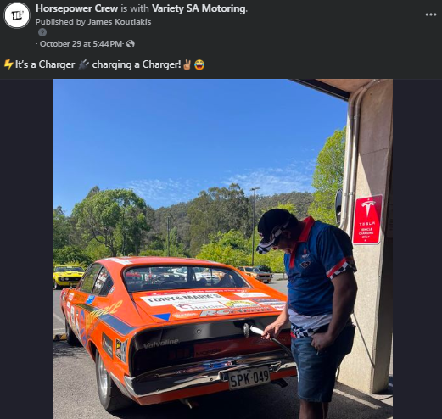
Date __________Activity Type________Reacts:______Comments___ Reach____Plays____Mins Viewed_______________________Value
29th Oct Reel 32 5 1,011 4,100 330 $25
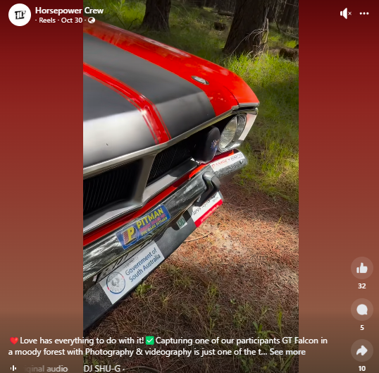
Hold Cntrl + Click the pics above to go to Facebook to view
Services Statement
Page: 9
Date __________Activity Type_________Reacts:______Comments___ Reach______Plays_____Other clicks_____________________Value
30th Oct Livestream 87+16 39+2 1,617+335 2,500+390 126+35 $150
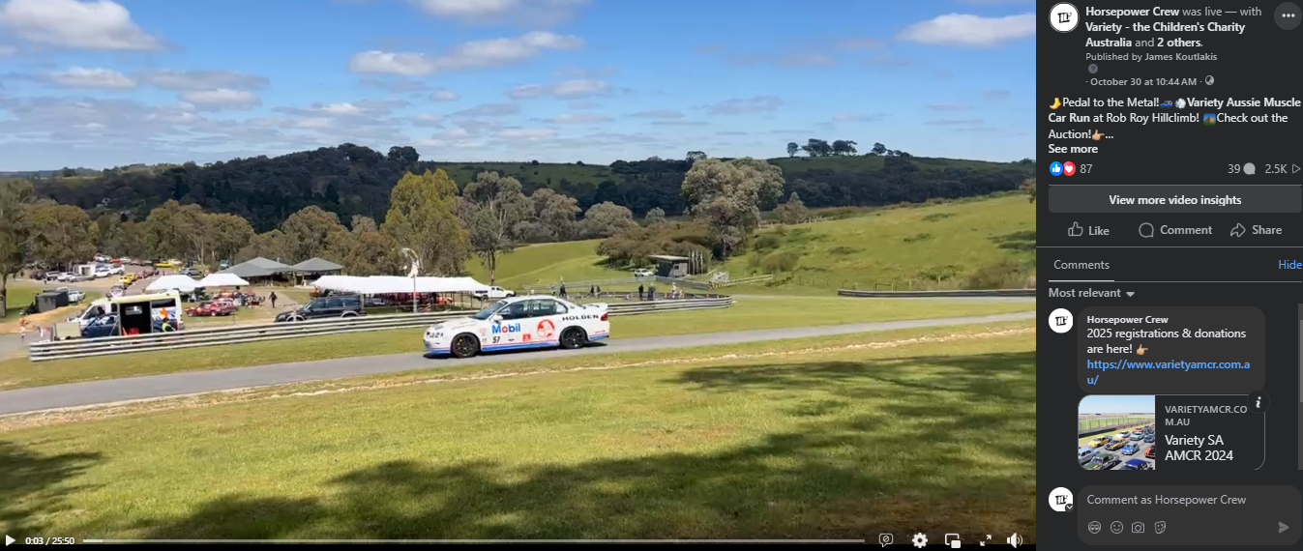
Date __________Activity Type________Reacts:______Comments___ Reach___Impressions____Other Clicks____________________Value
30th Oct Photo 26+2 4 2,313 2,439 70 $75
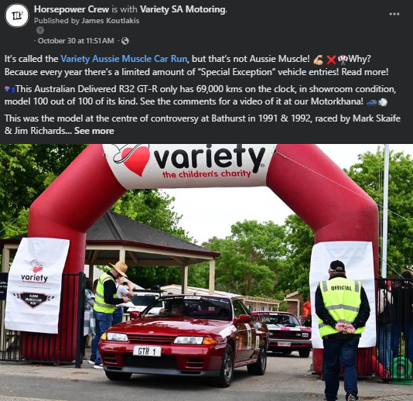
Hold Cntrl + Click the pics above to go to Facebook to view
Services Statement
Page: 10
Date __________Activity Type_________Reacts:______Comments___ Reach___Plays_____Other clicks________________________Value
29th Oct Interview Video 18+19 2+2 1,303 1,300 161 $150
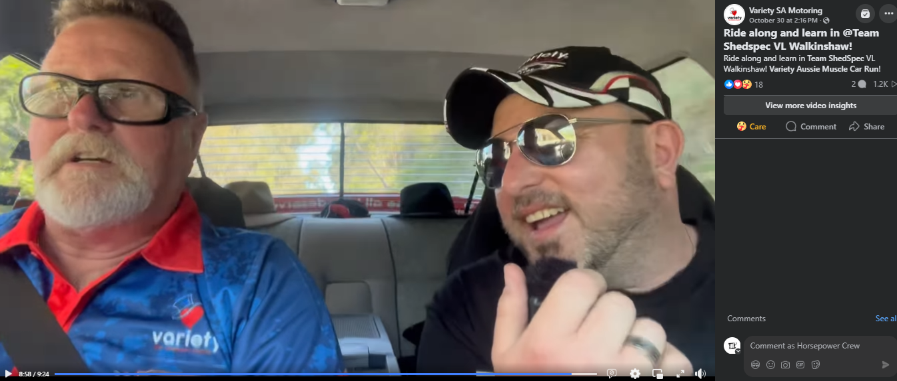
Date __________Activity Type________Reacts:______Comments___ Reach____Plays____Mins Viewed_______________________Value
30th Oct Reel 29 3 1,011+974 4,100 330+157 $25
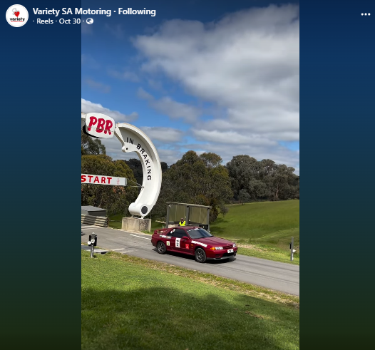
Hold Cntrl + Click the pics above to go to Facebook to view
Services Statement
Page: 11
Date __________Activity Type________Reacts:______Comments___ Reach____Plays____Mins Viewed_______________________Value
30th Oct Reel 39 1 1,474 2,000 246 $25
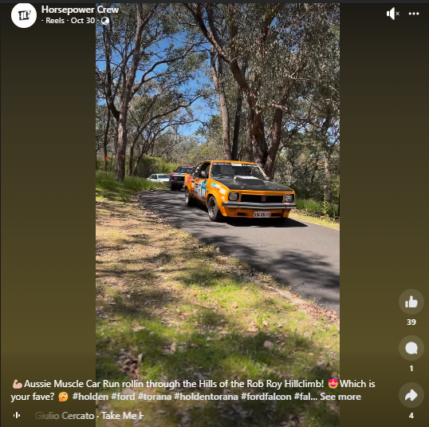
Date __________Activity Type_________Reacts:______Comments___ Reach___Plays_____Other clicks________________________Value
30th Oct Interview Video 49+3 5 2,049 3,800 241 $150
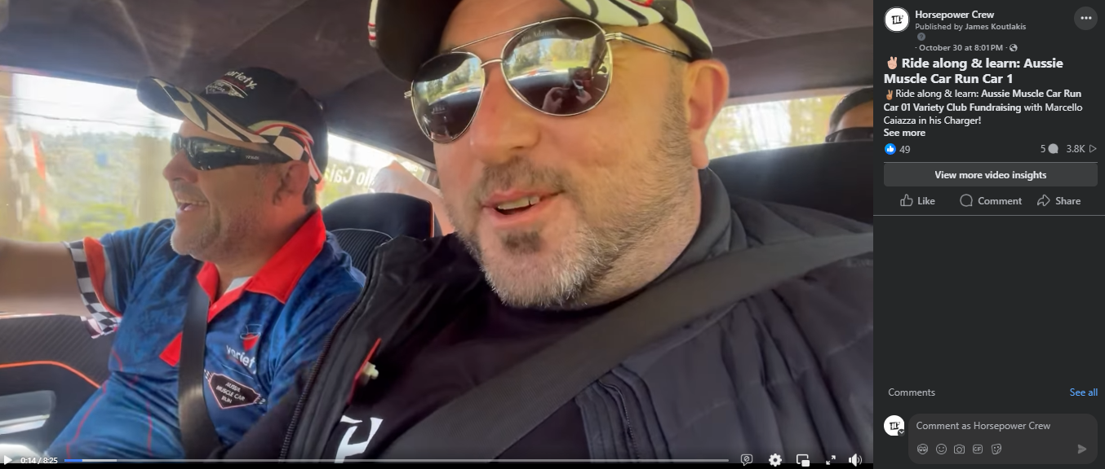
Hold Cntrl + Click the pics above to go to Facebook to view
Services Statement
Page: 12
Date __________Activity Type________Reacts:______Comments___ Reach____Plays____Mins Viewed_______________________Value
31st Oct Reel 44+6 6 1,744 5,300 474 $25
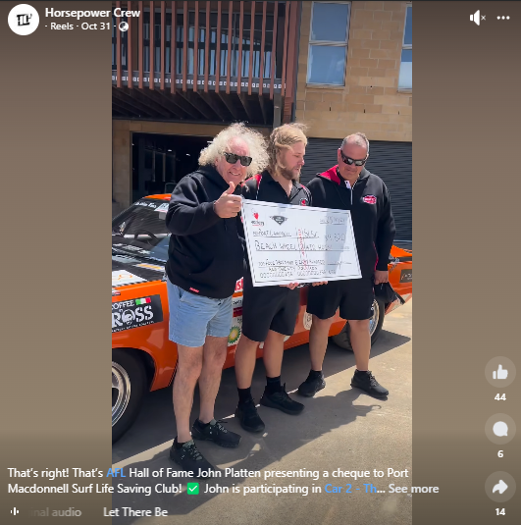
Date __________Activity Type_________Reacts:______Comments___ Reach___Plays_____Other clicks________________________Value
31st Oct Interview Video 87 11 2,689 3,600 238 $150
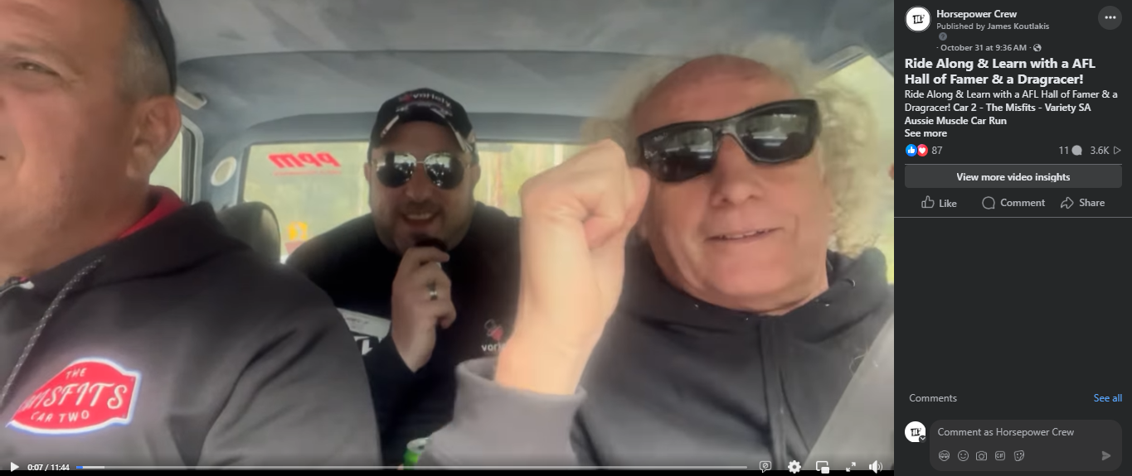
Hold Cntrl + Click the pics above to go to Facebook to view
Services Statement
Page: 13
Date __________Activity Type_________Reacts:______Comments___ _Reach______Plays_____Other clicks____________________Value
31st Oct Livestream 64+6 28+1 3,028+1,115 4,100+1,100 195+27 $150
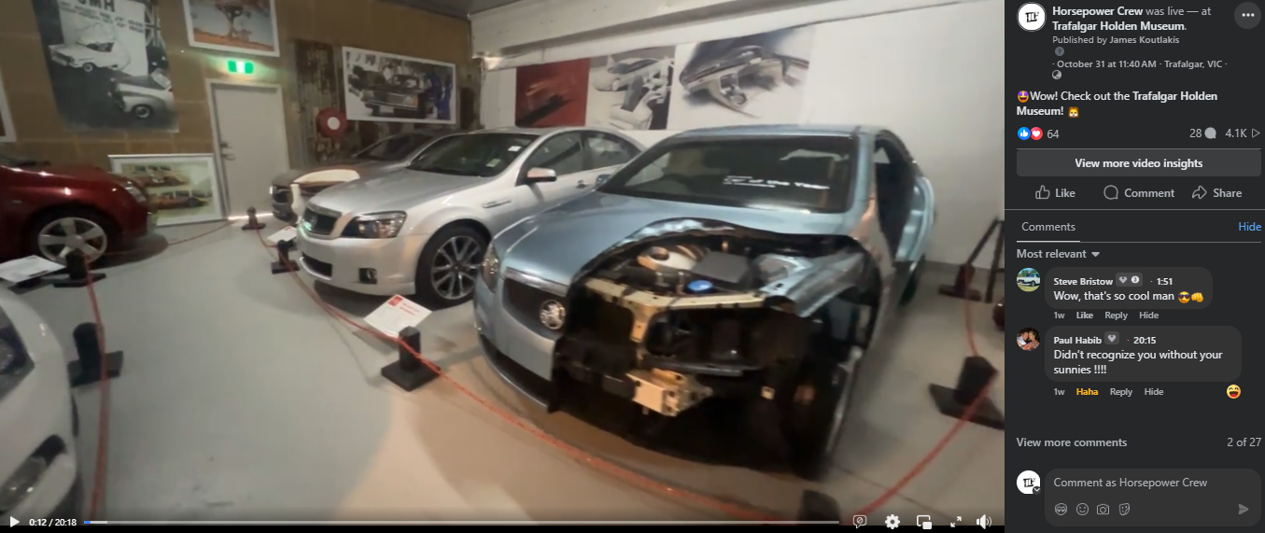
Date __________Activity Type_________Reacts:______Comments___ Reach______Plays_____Other clicks_____________________Value
31st Oct Livestream 51+11 20 1,626+292 2,900+317 93+22 $150
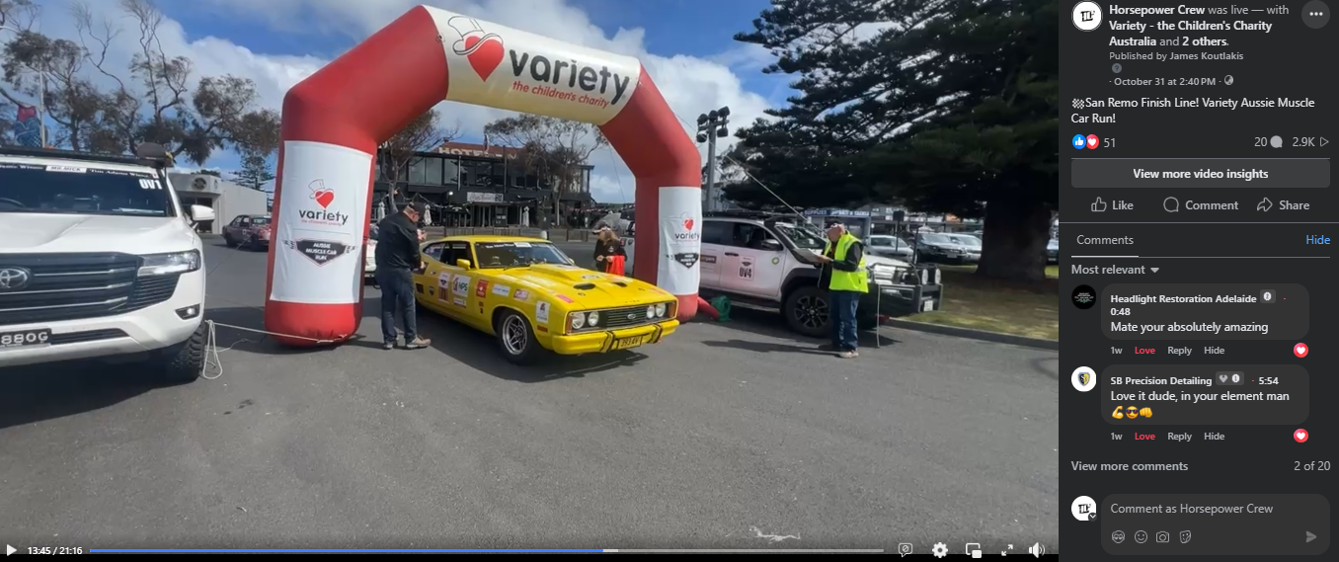
Hold Cntrl + Click the pics above to go to Facebook to view

Services Statement
Page: 14
Date __________Activity Type_________Reacts:______Comments___ Reach___Plays_____Other clicks________________________Value
31st Oct Interview Video 64+15 8+1 2,457 3,200 202 $150
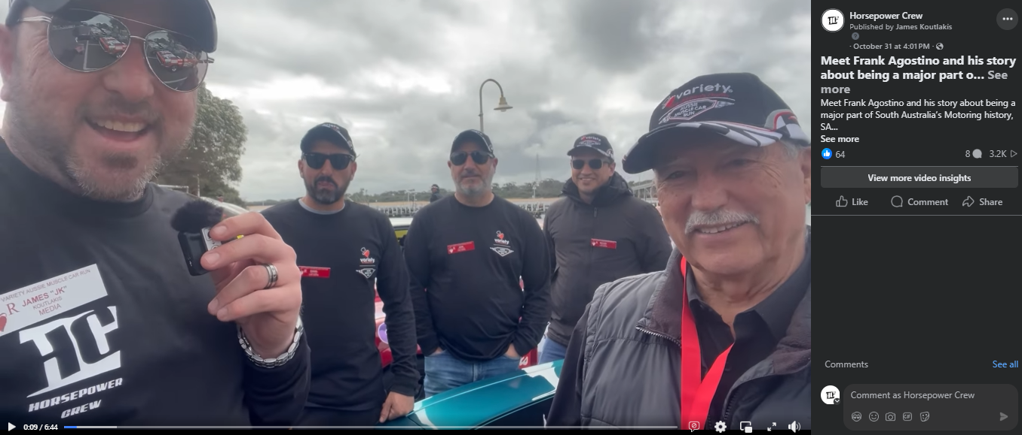
Date __________Activity Type________Reacts:______Comments___ Reach____Plays____Mins Viewed_______________________Value
1st Nov Reel 83+3 0 1,485 3,800 294 $25
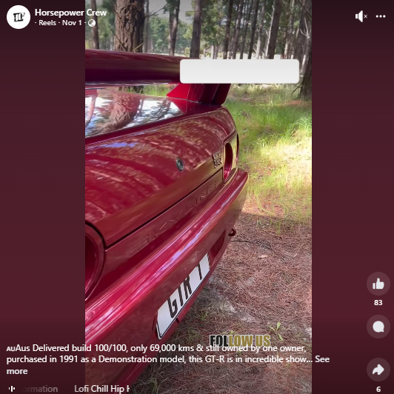
Hold Cntrl + Click the pics above to go to Facebook to view
Services Statement
Page: 15
Date __________Activity Type________Reacts:______Comments___ Reach___Impressions____Other Clicks____________________Value
1st Nov Photo 66 90 1,578 1,648 111 $75
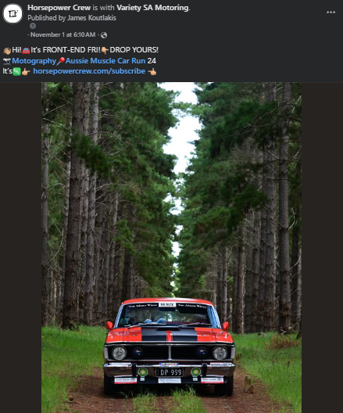
Date __________Activity Type________Reacts:______Comments___ Reach____Plays____Mins Viewed_______________________Value
1st Nov Reel 43+12 7 565 3,500 356 $25
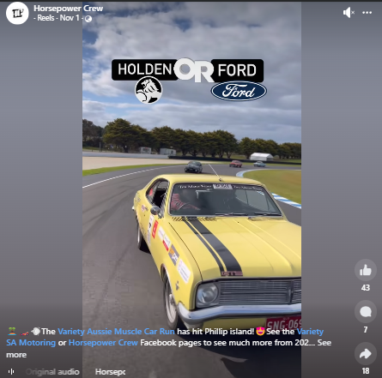
Hold Cntrl + Click the pics above to go to Facebook to view
Services Statement
Page: 16
Date __________Activity Type________Reacts:______Comments___ Reach____Plays____Mins Viewed_______________________Value
1st Nov Reel 25 0 2,615 4,600 434 $25
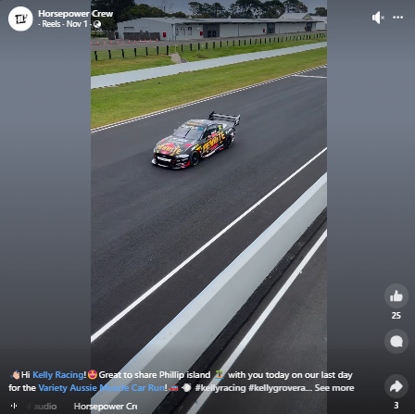
Date __________Activity Type________Reacts:______Comments___ Reach____Plays____Mins Viewed_______________________Value
1st Nov Reel 32+20 0 2,538 4,500 429 $25
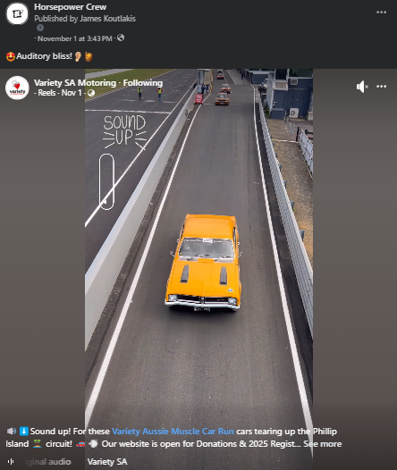
Hold Cntrl + Click the pics above to go to Facebook to view
Services Statement
Page: 17
Date __________Activity Type________Reacts:______Comments___ Reach____Plays____Mins Viewed_______________________Value
2nd Nov Reel 35+4 0 1,617 4,600 382 $25
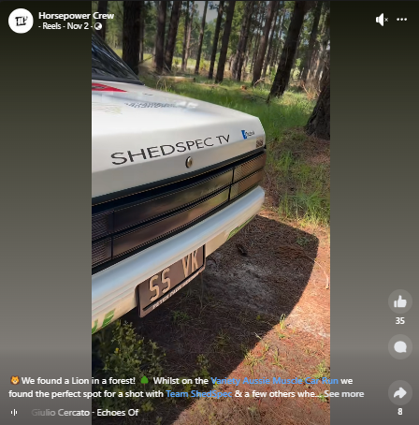
Date __________Activity Type________Reacts:______Comments___ Reach____Plays____Mins Viewed_______________________Value
2nd Nov Reel 27 1 1,617 4,600 382 $25
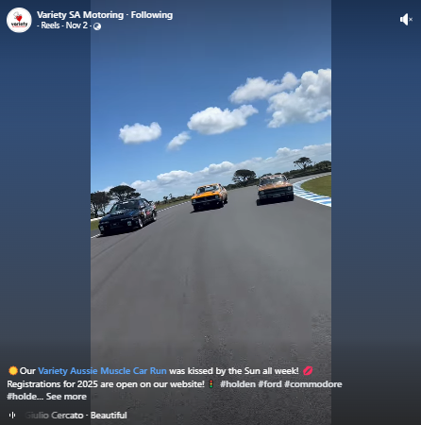
Hold Cntrl + Click the pics above to go to Facebook to view
Services Statement
Page: 18
Date __________Activity Type________Reacts:______Comments___ Reach____Plays____Mins Viewed_______________________Value
3rd Nov Reel 39+7 3 625 6,400 505 $25
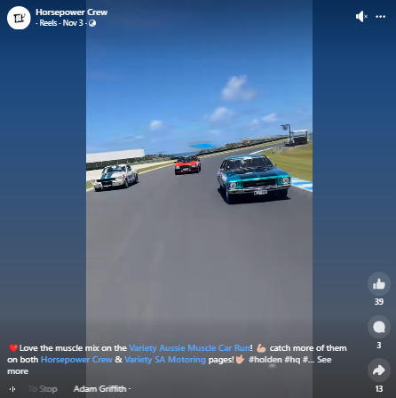
Date __________Activity Type________Reacts:______Comments___ Reach___Impressions____Other Clicks____________________Value
1st Nov Photo 66 90 1,578 1,648 111 $75
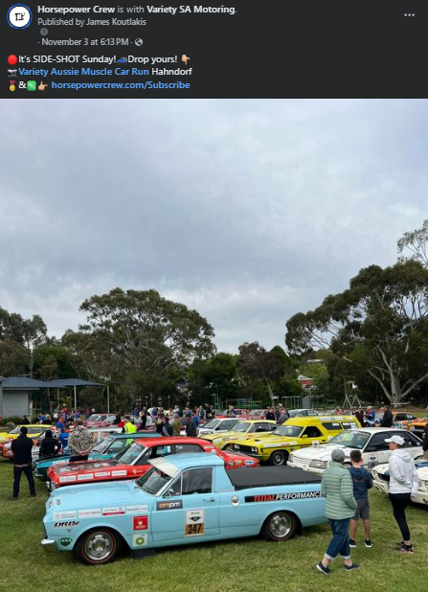
Hold Cntrl + Click the pics above to go to Facebook to view
Services Statement
Page: 19
Date __________Activity Type________Reacts:______Comments___ Reach____Plays____Mins Viewed_______________________Value
4th Nov Reel 108+8 2 943 9,600 1,100 $25
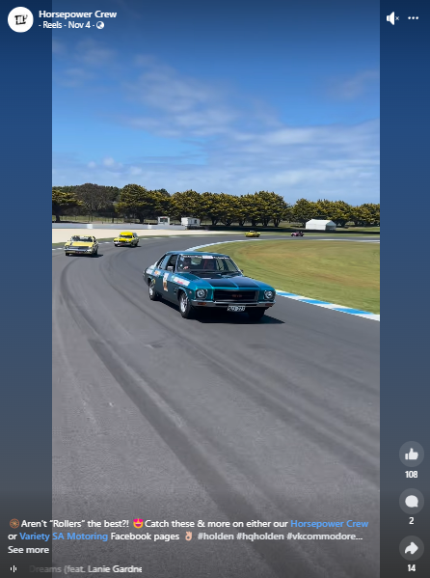
Date __________Activity Type________Reacts:______Comments___ Reach___Impressions____Other Clicks____________________Value
28th Oct Photo 15 1 1,510 1,510 41 $75
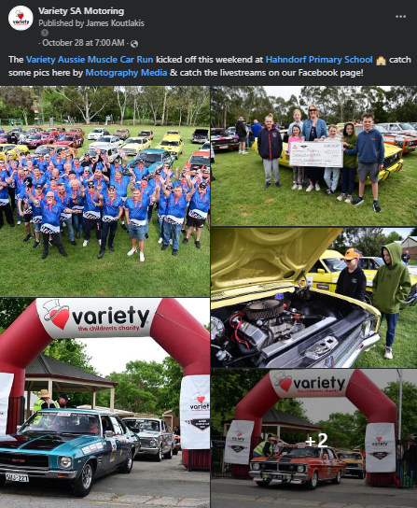
Hold Cntrl + Click the pics above to go to Facebook to view
Services Statement
Page: 20
Date __________Activity Type_________Reacts:______Comments___ Reach___Plays_____Other clicks________________________Value
31st Oct Interview Video 19 1 982 1,500 90 $150
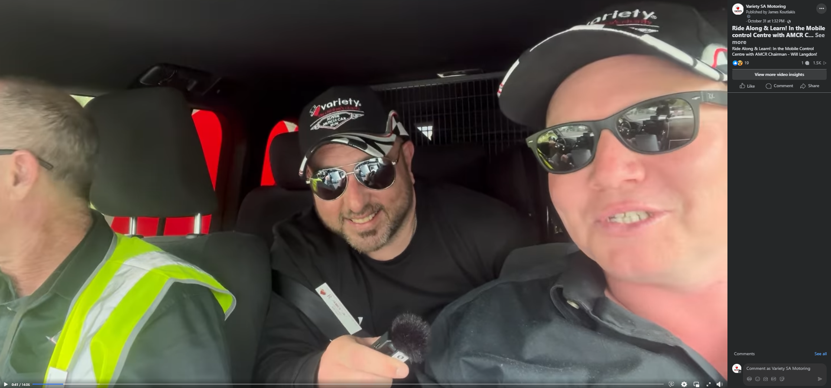
Date __________Activity Type_________Reacts:______Comments___ Reach___Plays_____Other clicks________________________Value
1st Nov Interview Video 14 1 522 587 14 $150
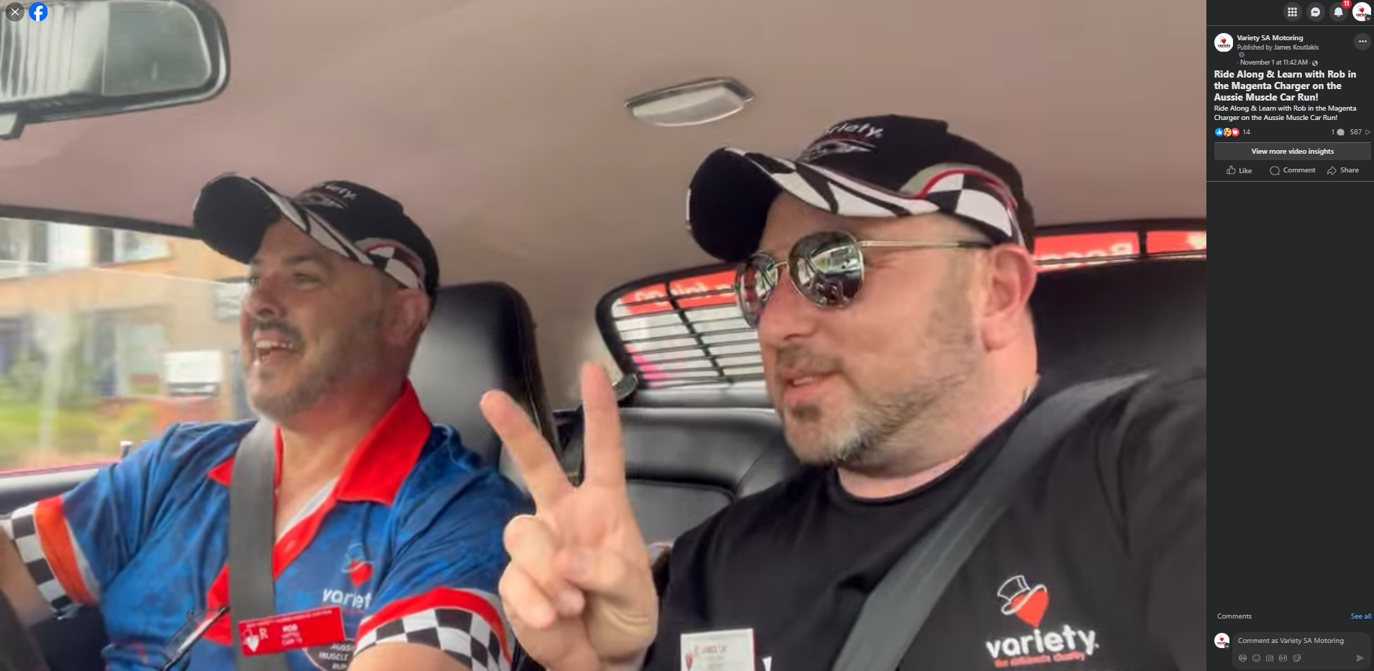
Hold Cntrl + Click the pics above to go to Facebook to view

Services Statement
Page: 21

Total Summary:
11 day Period - 25thOct - 4th Nov (agreement was 7)
Posts: 42 (Agreement was 21)
Reacts: 4,139
Comments: 778
Reach: 137,360
Plays: 251,837
Other Clicks: 4,670
Value: $3,550
Paid: $1,575
Extra Value: $1,975

Continue to View data on the growth of the Variety SA Motoring page as a result of our endeavour to have a positive impact on Variety AMCR on the last few pages ahead

Services Statement
Page: 22
Facebook reach increased by 626% over the previous 28 days
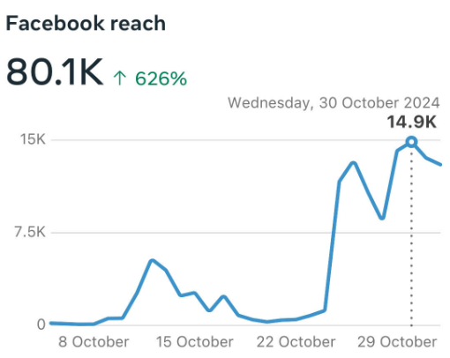
Facebook reach increased by 66.7% over the year
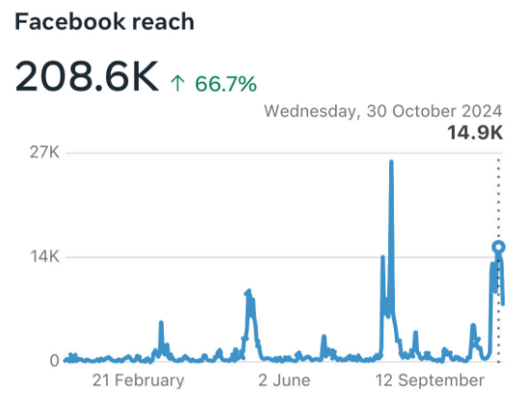

Services Statement
Page: 23
Facebook Follows increased by 642% over the previous 28 days
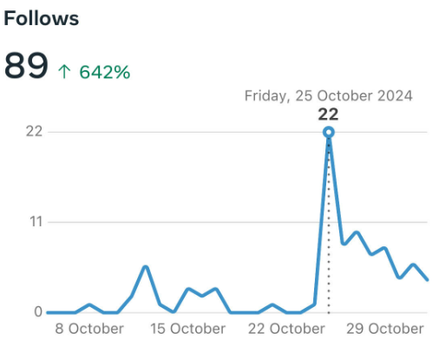
Facebook follows were the 2nd highest in the year
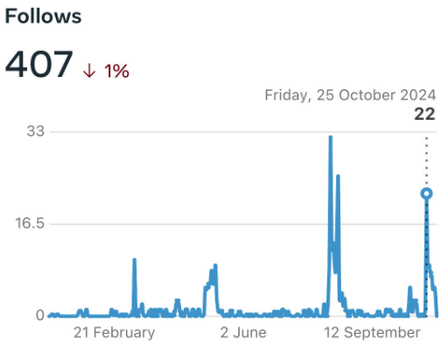
Services Statement
Page: 24
Facebook Page visits grew 562% over the previous 28 day period
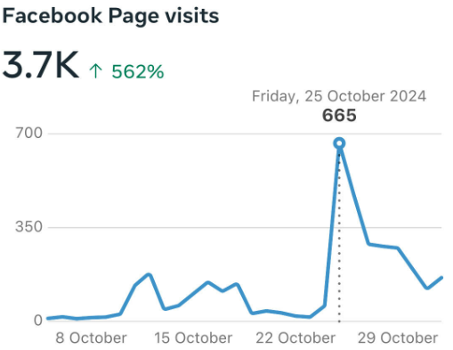
Impressions and engagement results were astronomical in results
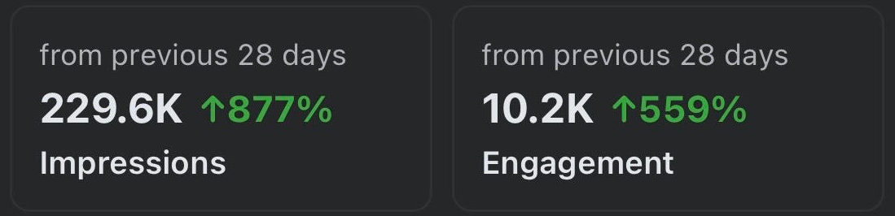
Thank you so much for your support of South Australia’s Motoring Enthusiast Community Organisation! We hope that you are very pleased with the engagement, reach and association of your great business with our brand and community so far. We look forward to meeting with you to discuss any of the above data from your service statement.

