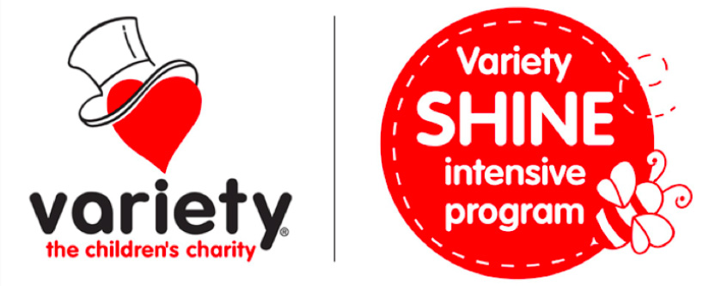
Variety and the Andrew Dean Fildes Foundation for Language-Learning Disabilities in conjunction with Dr Carl L Parsons & Associates Pty Ltd of the Centre for Advanced Assessment & Therapy Services are in the process of collecting pictures, movies and sounds for use in videos, dvds, and the internet to familiarise the community about the problems of children with Language-Learning Disabilities, their families, and their schools.

The purpose is to provide the community with information about the nature, problems, and treatment programs available. We are particularly keen to promote the Fildes Foundation and its SHINE programs. Thus, we are in the process of collecting digital pictures (photographs), movies and sound files which will be combined with text to demonstrate our programs and highlight what has been accomplished by children in our programs. This material will be used in lectures, workshops, seminars, conferences, and will be used to generate income for the Foundation. This information will be used on the internet and in promotional materials to highlight our programs.

In some instances, the materials will be used for promotion of the Foundation and by the Centre for Advanced Assessment and Therapy Services in brochures or media releases and also to demonstrate high quality treatment techniques at workshops for teachers, parents, and other professionals..

We believe your child would be an excellent example to demonstrate these techniques Thus, we would like your permission to take photographs, make videos, and record speech samples of your child as he/she works with us or in a recorded interview.

None of the material selected will attempt to place your child or any of the participants in a stereotyped or negative situation. Indeed, we want to show the positives.

It is also our intention to use your child’s first name in our material. But no family names (last names) will be used. (If this concerns you please discuss this with us).

If you have any questions about the collection or use of these materials please contact Dr. Carl L. Parsons on 040-335-4149 or at parsons.carl.c@edumail.vic.gov.au

If you agree that we can use the materials as described please sign the form below and return the form to Dr Parsons or Andrew Fildes.

Thanks for your cooperation.

I agree that Variety and the Andrew Dean Fildes Foundation (SHINE) and Dr Carl L Parsons & Associates Pty Ltd can collect and utilise the video/photographic/audio materials for the purposes of promoting Variety, the Foundation and helping the community to understand Language-Learning Disabilities and how children can benefit from programs. I understand that this material will also be used to generate donations to the Foundation and used to teach others about how to help children with language-learning disabilities.

I give permission for the media materials for my child _____________________ to be utilised.

I understand that the materials may be used for lectures, workshops, seminars, conferences, and will also be placed on the internet or used in multimedia programs.

The materials will also be utilised for promotional purposes.

None of the material will identify my child by family name and will emphasise the positive aspects of my child.

I acknowledge that I have agreed for these materials to be utilised on a voluntary basis and that the use of the materials does not give me any right to require payment; now or in the future.

I release Variety and the Andrew Dean Fildes Foundation and Dr Carl L Parsons & Associates Pty Ltd from any liability arising out of the use of this material.

Any questions I have asked have been answered.

___________________________ ________________________
Parent/Guardian (Print & Sign) Parent/Guardian

Date: Date: __________________

Child’s Signature (if applicable)

Please note any special requests in the space below:

