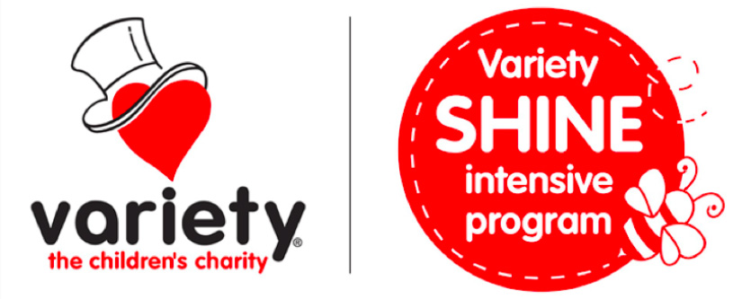

AUDIO/VIDEO ASSESSMENT & IMPROVEMENT EVALUATION FORM

Variety and the Andrew Dean Fildes Foundation for Language-Learning Disabilities (Variety-SHINE) in conjunction with Dr Carl L Parsons & Associates Pty Ltd of the Centre for Advanced Assessment & Therapy Services sometimes need to make audios or videos of your child speaking or reading. We do not need to show your child’s face and often audios are suitable.

The purpose of these audios / videos is to ensure we have an accurate evaluation of your child’s speech and / or language skills. By using the audio/video we can ensure we have examined speech, language, literacy and social skills accurately.

These audios / videos also become part of your child’s records with us. They can be used for comparisons of progress and to plot data on progress.

None of the material selected will attempt to place your child or any of the participants in a stereotyped or negative situation. Indeed, we want to show the positives.

From time to time, we like to use these audios / videos to teach University students and other professionals how to analyse data or show progress.

If you have any questions about the collection or use of these materials please contact Dr. Carl L. Parsons on 040-335-4149 or at carl.parsons@shine.org.au

Please sign the form below and return the form to Dr Parsons.

Thanks for your cooperation.

VIDEO ASSESSMENT & IMPROVEMENT EVALUATION FORM

I agree that Variety and Andrew Dean Fildes Foundation (Variety-SHINE) and Dr Carl L Parsons & Associates Pty Ltd can collect and utilise the audio / video materials for the purposes of assessment and evaluating my child’s progress.

I give permission for audio / video recordings for my child _____________________ to be utilised in assessment and evaluation of progress.

I understand that the materials may also be used for lectures, workshops, seminars, conferences.

None of the material will identify my child by family name and often my child’s face may not be seen; there will be a preference for audio recordings when possible. The recordings will emphasise the positive aspects of my child.

I acknowledge that I have agreed for these materials to be utilised on a voluntary basis and that the use of the materials does not give me any right to require payment; now or in the future.

I release Variety and the Andrew Dean Fildes Foundation and Dr Carl L Parsons & Associates Pty Ltd from any liability arising out of the use of this material.

Any questions I have asked have been answered.

___________________________ ________________________
Parent/Guardian (Print & Sign) Parent/Guardian

Date: Date: __________________

Child’s Signature (if applicable)

Please note any special requests in the space below:

